# ERD:

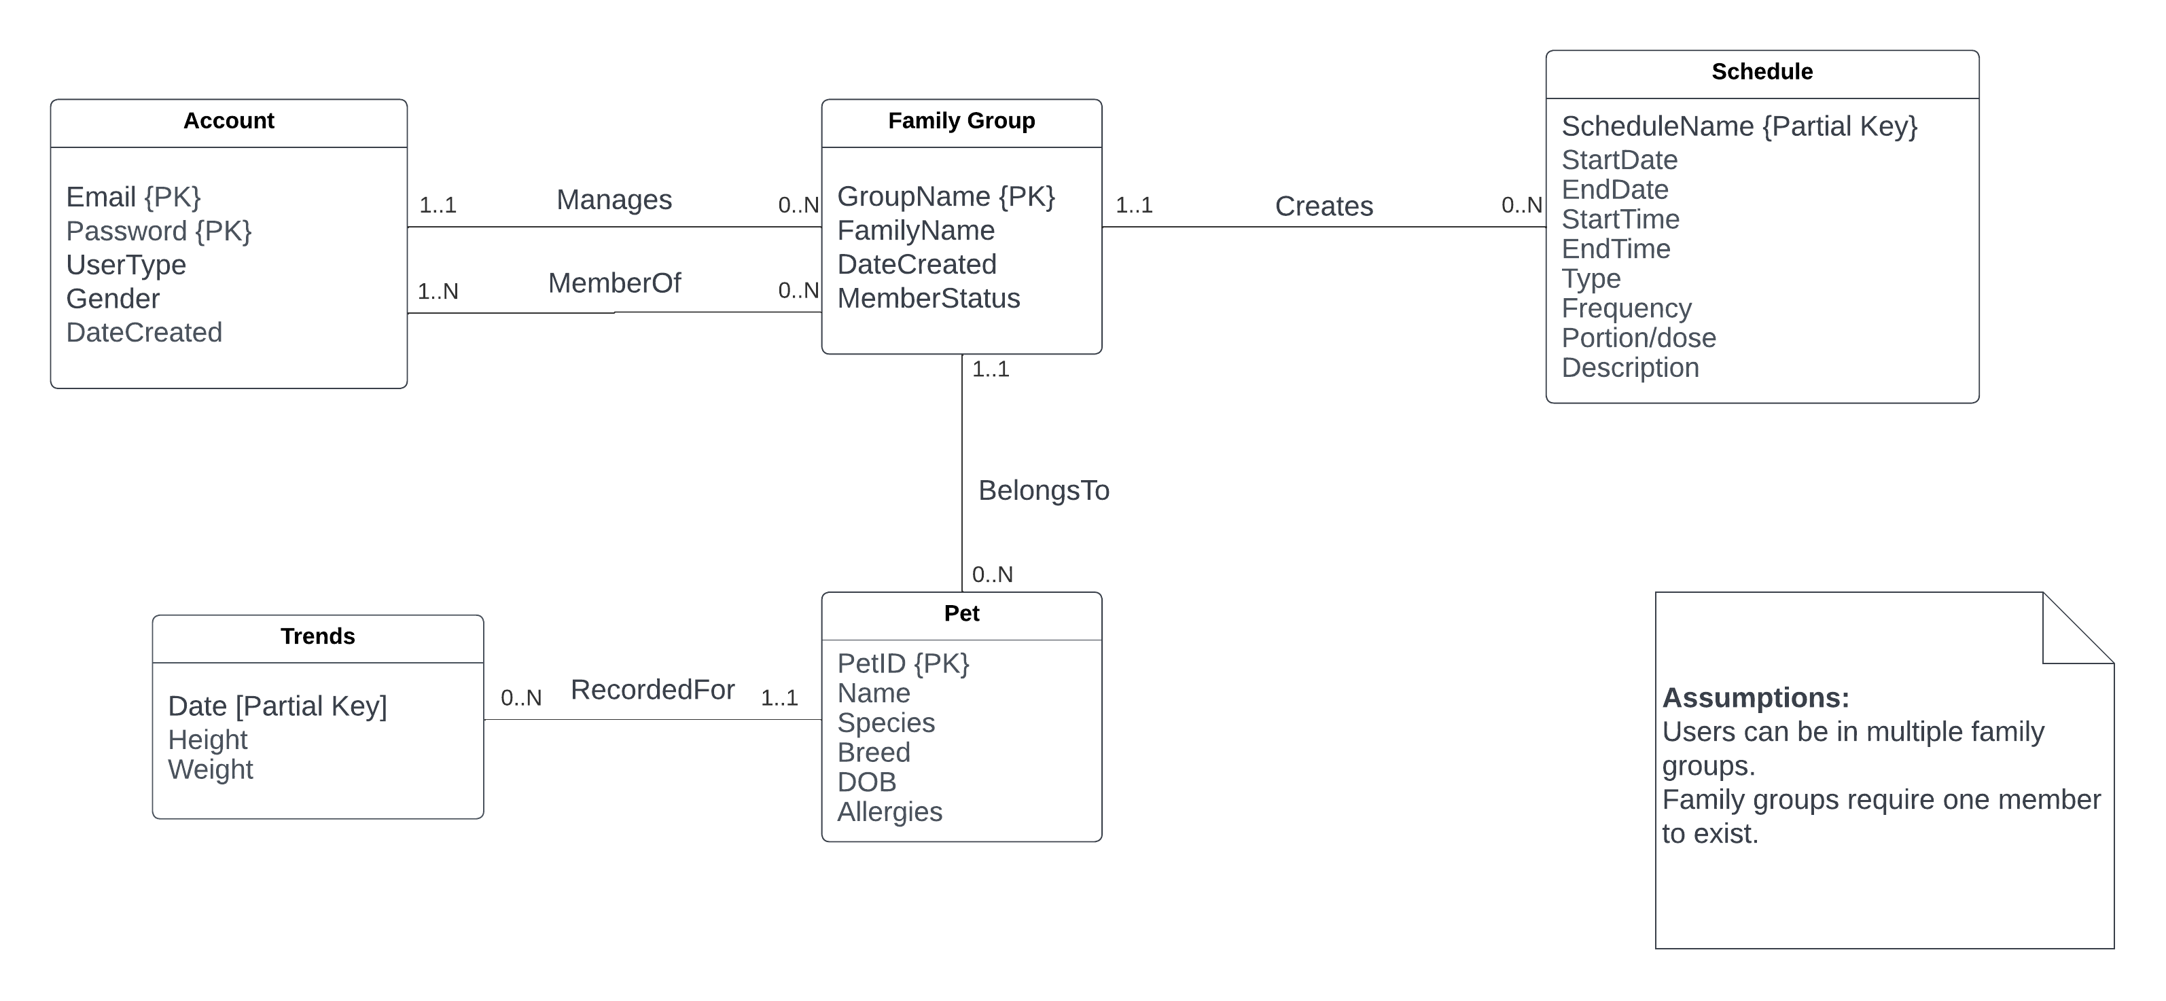

# Schema:

## Step 1: Map entities

Account (Email, Password, UserType, Gender, DateCreated)

Member_Of (Email*, Password*, GroupName*)

Family_Group (GroupName, FamilyName, DateCreated, MemberStatus)

Schedule (GroupName*, ScheduleName, StartDate, EndDate, StartTime, EndTime, Type, Frequency, Portion/dose, Description)

Pet (PetID, Name, Species, Breed, DOB, Height, Weight, Allergies)

Trends (PetID*, Date, Height, Weight)

## Step 2: Map relationships

Account (Email, Password, UserType, Gender, DateCreated)

Member_Of (Email*, Password*, GroupName*)

Memberships (UserID*, GroupName*)

Family_Group (GroupName, FamilyName, DateCreated, MemberStatus, AdminUserID*)

Schedule (GroupName*, ScheduleName, StartDate, EndDate, StartTime, EndTime, Type, Frequency, Portion/dose, Description)

Pet (PetID, Name, Species, Breed, DOB, Height, Weight, Allergies, GroupName*)

Trends (PetID*, Date, Height, Weight)

## Step 3&4: Map multivalued attributes and higher degree relationships

[ERD has none so skip these steps.]

## Final Schema:

Account (Email, Password, UserType, Gender, DateCreated)

Member_Of (Email*, Password*, GroupName*)

Memberships (UserID*, GroupName*)

Family_Group (GroupName, FamilyName, DateCreated, MemberStatus, AdminUserID*)

Schedule (GroupName*, ScheduleName, StartDate, EndDate, StartTime, EndTime, Type, Frequency, Portion/dose, Description)

Pet (PetID, Name, Species, Breed, DOB, Height, Weight, Allergies, GroupName*)

Trends (PetID*, Date, Height, Weight)